

Important information about changes to the Loughborough Sexual Health Service
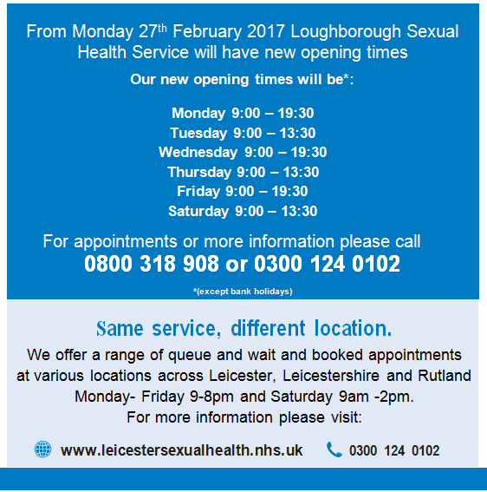
The Sexual Health Team are continuously working to improve the Sexual Health Service across Leicester, Leicestershire and Rutland.

